**Grove - Hall Sensor**

窗体顶端

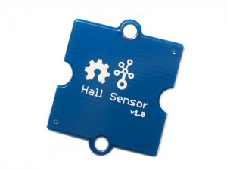

http://www.seeedstudio.com/depot/includes/templates/pure_green/images/next_l.gif

* [http://www.seeedstudio.com/depot/bmz_cache/2/253900b07d200415e40cad7d6a8e1da6.image.55x41.jpg](http://www.seeedstudio.com/depot/images/product/hall%20sensor.jpg)
* [http://www.seeedstudio.com/depot/bmz_cache/b/b04cd3b65ab5d5a57e12fcc4d7620a12.image.55x41.jpg](http://www.seeedstudio.com/depot/images/product/hall%20sensor_01.jpg)

http://www.seeedstudio.com/depot/includes/templates/pure_green/images/next_r.gif

* **Price:**

$5.95  [(Price Feedback)](javascript:void())

* **SKU:**

SEN14034P

* **Weight:**

2Gram

* **Units in Stock**

10

* **Designed by:**

[Seeed Studio](http://www.seeedstudio.com/)



[Other products from designer](http://www.seeedstudio.com/depot/seeed-studio-m-23.html)

* **Quantity:** Max: 10  
  
* [Add to Wish List](http://www.seeedstudio.com/depot/index.php?main_page=un_wishlist&products_id=965&cPath=144_154&action=un_add_wishlist)

Description

The Hall Sensor measures the Hall Effect, which is a production of a voltage difference across an electrical conductor, transverse to an electric current in the conductor as well as a magnetic field perpendicular to the current. The output of the continuous-time switch Hall sensor on this Twig switches low and turns on when a magnetic field (south polarity) perpendicular to the Hall sensor exceeds the BOP threshold, and it switches high and turn on when the magnetic field disappears.

**Features**

* Grove compatible interface
* 400ns transition period for rise and fall.
* Continuous-time hall effect sensor

**Application Ideas**

* RPM meter.
* Simple dc motor.

**Mechanic Dimensions**

20mm by 24mm

**Documents**

Please visit our [wiki page](http://www.seeedstudio.com/wiki/Grove_-_Hall_Sensor) for more info about this product. It will be appreciated if  you can help us improve the documents, add more demo code or tutorials. For technical support, please post your questions to our [forum](http://forum.seeedstudio.com/).

窗体底端